

**Corporate Sustainability Report – 2022**

**ENERGY USE.**

**Background.** Stony Creek Quarry Corporation (SCQC) is committed to using as little energy as possible in its dimension stone operations. For purposes of this report, dimension stone is defined as all products sold other than crushed aggregate. These products include:

* Dimension block
* Armour stone for seawalls
* Split Veneer for masonry walls
* Boulders and character stones

Stony Creek Quarry has set a goal of reducing its energy consumption per ton of stone produced by 5%/year over a period of the next 5 years – from roughly 1 million kWhrs now to 750,000 kWhrs by 2027. This will be accomplished primarily by securing on-grade access to the Active Quarry. Off-road diesel consumption, our primary energy usage (about 76% of total kWhrs), is expected to decrease dramatically once this is accomplished. Also, we anticipate a future reduction in overburden removal from the high levels existing in 2016-22.

**Big drop in 2022 (relatively speaking). O**ur energy usage dropped from 53 kilowatt hours (kWhrs) per ton of stone produced in 2021 to 48 kWhrs in 2022. (kWhrs are a good way to common-size all kinds of energy use).

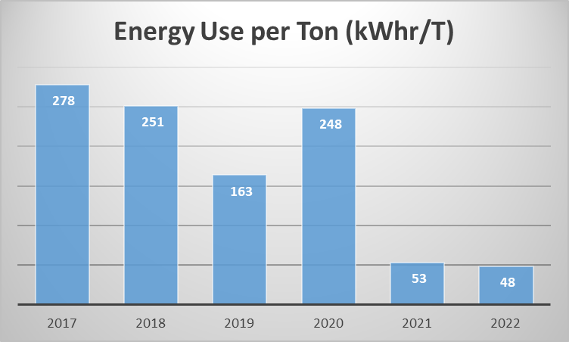

Figure 1. Energy Use Per Ton of Production.

This drop (9%) is primarily due to a 10% increase in stone production and a modest (8%) decrease in energy usage, primarily in diesel usage. The increase in production was all due to an increase in armour stone production for a big job of shoring up the breakwater around the historic Montauk Point Lighthouse. Rising sea levels and increasing severity of storms were eroding the point and the Stony Creek Granite armour stone was ideal to increase the facility’s resilience. See Figure 2 below.

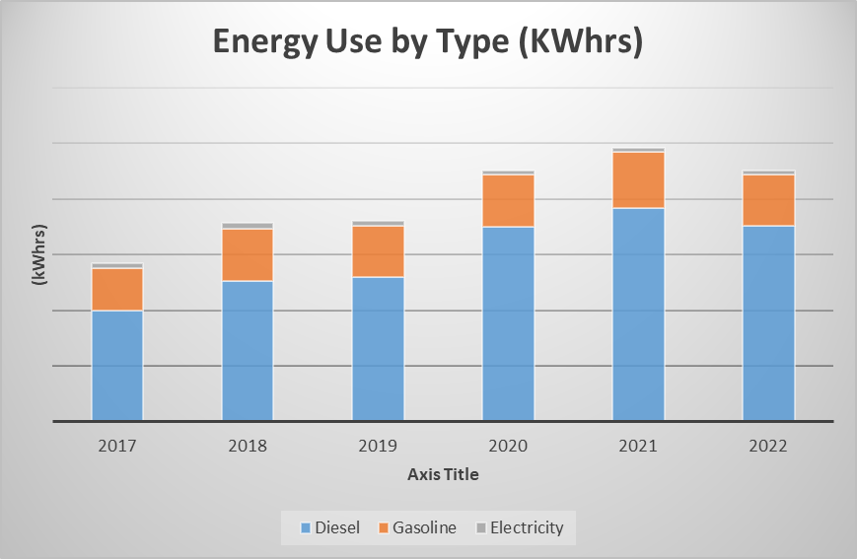



Figure 2. Energy Use by Type.

**Major decreases.** Our total energy usage decreased in 2022 from 2021 by about 8% led by a like decrease in diesel and gasoline consumption. We have tried to make incremental progress on reducing the big consumption categories such as transport of stone from the Active Quarry to the lower levels where we load tractor trailer trucks but until we finish quarrying a roadway into it, we need to rely on the big frontend loaders that consume so much diesel. And we continue to watch for the development of the next generation fuel cell powered vehicles that may banish diesel from the quarry. Komatsu expects their line of hydrogen fuel cell machines to come to market in 2030….

**EXCESS PROCESS MATERIALS and SOLID WASTE.**

We have a “zero-waste” policy for granite; 100% of our stone is valuable and is sold for useful products. While dimensional block production is the goal of all our planning and operations, we process all the rest of the granite into other products such as crushed stone of various specifications, wall stone, and landscaping materials.

As new areas of the quarry are readied for development, we reserve the topsoils for future reclamation and use it in berms to protect areas adjacent to the quarry from runoff. These topsoil reserves are deemed “excess process materials” under the NSI 373 Standard (EPM). Our goal is to produce as little EPM as possible. Our EPM production, normalized for the dimension stone production each year is as follows (expressed in tons of EPM per ton of production):



We generate nominal quantities of solid waste and recyclable consumer products. All waste oils and hazardous materials are professionally disposed of through licensed third parties. Our production of solid waste (including scrap steel which we sell to recyclers such SIMS Metal) normalized for the dimension stone production each year is as follows (expressed in tons of solid waste per ton of production):



**WATER.**

All the water used in our operations is rainwater that we collect on-site. After use for washing, cooling or crushing stone, we recover over 95% of this water for re-use.

**SITE MANAGEMENT.**

We are proud of our location within the Stony Creek Quarry Preserve, a 300 acre parcel of natural open space which is owned by the Town of Branford. This land is contiguous to another 1,000 acres owned by the Branford Land Trust and Guilford Land Conservation Trust and forms a natural corridor for wildlife with rare access from Long Island Sound into wooded uplands.

Within this larger landscape, we take care to efficiently extract stone without disturbing non-quarried terrain within our lease area.

**SAFETY.**

Our excellent safety record has earned us numerous safety awards over the last ten years from MSHA, the Mine Safety and Health Administration.

**EDUCATION.**

In 2020 and 2021, COVID-19 closed most public tours of the quarry. 2019 was a more normal year - we proudly hosted over 600 students, architects, builders, politicians (including Congresswoman Rosa DeLauro and Senator Richard Blumenthal), professors and other community members. Our visitors included delegations from the U.S. National Park Service, the New York Parks Department, CT chapter of the American Institute of Architects and Yale and Wesleyan Universities. In 2022, we restarted tours with Yale and Wesleyan geology classes and touring groups from New York City.

We are particularly interested in reaching out to the children of Branford and Guilford, CT in order that they can understand the historical connection between the Quarry and these two shoreline towns. Our goal is that all third graders from these towns come to the Quarry for a field trip. We are determined on to evolve in creative ways and to be stewards of both the land on which the Quarry operates and the history of this dynamic operation.