**Corporate Sustainability Report – 2020**

**SUMMARY.**

Independent Limestone Company, LLC (ILC) wants to operate it business in the most responsible and sustainable manner that it can – that means to reduce its environmental impact and to treat its workers, vendors, customers and neighbors with respect. Certifying to the ANSI/NSI 373 Sustainable Production of Natural Dimension Stone (NSI 373) is a way to show the world that ILC is striving for excellence and constant improvement.

And while we know that we are not yet perfect, we are committed to reporting on our progress in a very public fashion. The materials below will give the reader a sense of our progress.

**ENERGY USE.**

ILC is committed to using as little energy as possible in both its quarry and its mill operations.

**Quarry.** Over the last 5 years from 2016 to 2020, our total energy usage in the quarry has increased slightly from 206 to 249 kilowatt hours (kWhrs) per ton of stone produced. (kWhrs are a good way to common-size all kinds of energy use). Obviously, tonnage of production is a key variable as is production yield. Production yield depends heavily on color and grain variation in the ledges from which block is cut and is largely uncontrollable.

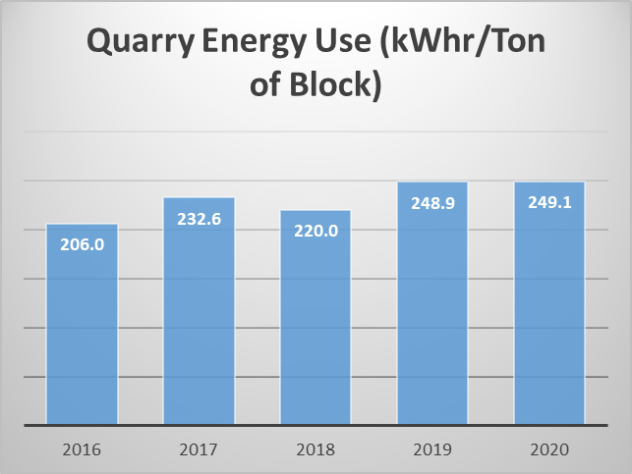

Figure 1. ILC Quarry Energy Use Per Ton of Dimension Stone. Source: “ 2020 ILC Quarry 10.1,10.2” --🡪”Graph2”.

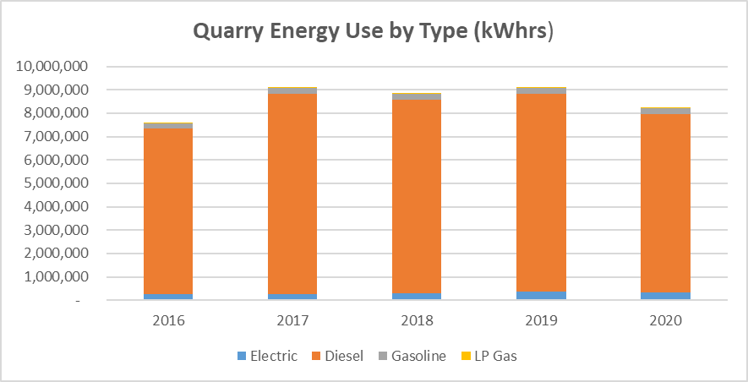



Figure 2. ILC Quarry Energy Use by Type of Energy (kWhrs). Source: “ 2020 ILC Quarry 10.1,10.2--🡪”Graph2”

ILC has set a goal of reducing its energy consumption per ton of stone produced by 1%/year over a period of the next 5 years. We reduced absolute total energy use by 9.5% in 2020 compared to 2019 with good reductions of all major categories. On a kWhrs/ton of production, our numbers were pretty flat due to a drop in total tons of block produced but we are proud that our energy usage seems headed in the right direction.

Off-road diesel consumption, our primary energy usage (93% of total quarry energy usage in 2020), will be reduced by monitoring heavy equipment traffic, improving efficiencies in engine performance and reducing haul mileage. Overburden removal accounts for much of diesel use.

Pumping water onto and out of the production ledges (the big saws which cut the limestone into blocks need water to lubricate the sawing process) accounts for most of electricity use (4% of total energy in 2020).

**Mill.** Energy use per ton of finished products (primarily treads, slabs and paving) has been relatively stable in the last four years. Note that the relative energy for processing finished production is less than half of the energy for extracting raw block in the quarry.

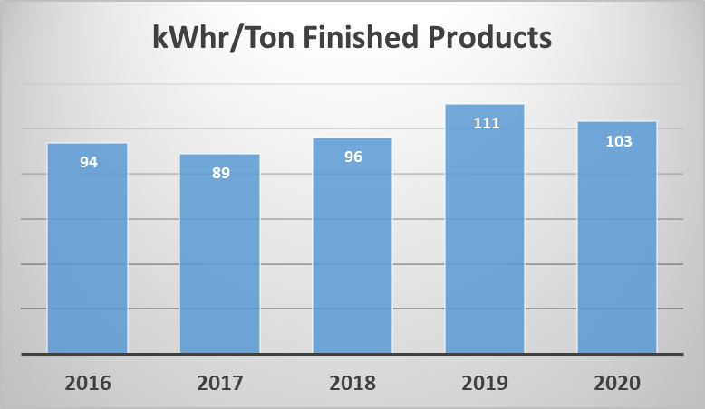

Figure 3. ILC Mill - Energy Use Per Ton of Finished Production. Source: “ 2020 ILC Mill 10.1,10.2”🡪”Charts”.

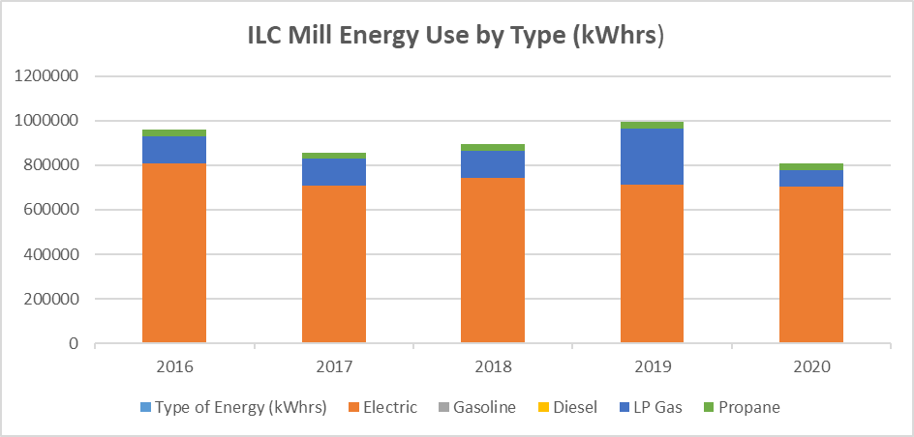

Figure 4. ILC Mill - Energy Use by Type. Source: “ 2020 ILC Mill 10.1,10.2”🡪”Charts”.

Our goal for energy reduction is to reduce our per ton kWhrs use by about 1% per year. In 2020, our use per ton of production declined 7% from 111 to 103kWhrs/ton and 19% in absolute usage. In 2020, electricity accounted for 87%, LP gas heating for 9% and forklift propane for 4% of Mill usage. We are continuing to look at ways of using renewable solar generated electricity to replace the relatively dirty coal powered electricity of the local grid.

**EXCESS PROCESS MATERIALS and SOLID WASTE.**

**Quarry.** Excess process materials (EPM) are all rock that we do not sell or reserve for regrading and rehabilitation of quarried areas. We make every effort to maximize the sale of block from our ledges by carefully handling the materials to prevent breakage in the quarrying process. However, limestone is a natural material, laid down over time with all the variations that a million years can bring. Due primarily to color and grain choices, we sell only about 20% of the stone we quarry. The remainder is moved to our grout pile. About 50% of the overburden (limestone materials above the marketable seams) is crushed into aggregate.

Due to the increased sales of crushed stone, our EPM/ton of block has dropped from over 12 tons to 5.35 in 2020.

We generate nominal quantities of solid waste and recyclable consumer products. All waste oils and hazardous materials are professionally disposed of through licensed third parties. As seen below, we have little solid waste at the quarry.



Figure 5. Quarry EPM and Solid Wastes. Source: “2020 ILC Quarry11.1-.4 =>”11.2,11.3,11.4”

**Mill.** EPM at the Mill are the parts of the block that are unused (about 40% of the raw materials) and the fines from the sawing processes that are flushed into sedimentation ponds by the process water flowing through the Mill.

As can be seen below, in 2020, we reduced the waste stone per ton of finished production from 0.69 tons in 2019 to 0. 61 tons.



Figure 6. Mill EPM and Solid Wastes. Source: “2020 ILC Mill 11.1-.4 =>”11.2,11.3,11.4”

**WATER.**

All the water used in our operations is rainwater or snow melt that we collect on-site. After use for washing, cooling or crushing stone, we recover over 99% of this water for re-use in both the quarry and the mill.

**SITE MANAGEMENT.**

We own over 500 acres of land including about 160 acres of active quarry and mill operations. The remainder of this land is reserved for future quarry use or as buffering open space from residential developments occurring in the Bloomington area.

**Ecosystem boundary areas** have been established on some of the parcels that will not be quarried in the foreseeable future. These areas managed to preserve the ecosystem services that the natural open space provides to the surrounding area. ILC management restricts equipment use on these areas as well as inventory storage or mechanical transit. See ecosystem map below.

ILC management is committed to minimizing the ecological impact of its operations on the land, water and air resources around the quarry and mill operations. Roads and quarrying areas are sprayed regularly with water trucks during dry conditions; we take great care that no storm water runoff can get into the Clear Creek watershed and have recently spent large sums of money improving our storm water containment and management systems.

**SOCIAL ACCOUNTABILITY.**

ILC is a responsible member of the Bloomington community. All its workers are paid a fair wage and salaries under a strong union contract. Health and safety regulations are rigorously followed and all employees are trained under a detailed Mine Safety and Health Administration (MSHA) course of study with annual updates required. Personal protective equipment including ear, eye and toe protection (steel toed boots!) are mandatory and ILC has an admirable safety record. ILC even pays for the boots and other PPE needed.

ILC also contributes to non-profits in the community, giving both money and stone to local charities.



Figure 7. Ecosystem boundary areas.